Exploratory analysis
Of the 700 patients (Female = 306 (43.71%); Male = 394 (56.23%)), 227 had heart failure, and 473 did not.
For continuous variables stratified by heart failure status, patients with heart failure were more likely to be older have significantly lower ejection fraction and eGFR, and significantly higher NT-proBNP levels, and serum creatinine. For categorical variables stratified by heart failure status, hypertension, prior myocardial, diuretics, and atrial fibrillation were more prevalent in the heart failure group. For sex, BMI, heart rate, systolic blood pressure, diastolic blood pressure, smoking, diabetes, anaemia, and beta, the difference observed was non-significant (See Table 1).
Boxplots and interquartile range analysis revealed that NT-proBNP had the highest number of outliers (n = 45, 6.4% of observations). eGFR also displayed substantial outliers (n = 31, 4.4%), showing the range in kidney function among heart failure patients.
These findings support the use of log transformation for NT-proBNP in regression modelling to address skewness, however, in the final model it was retained for interpretability, as the continuous form remained highly significant in all models (p < .001), indicating that the skewness did not negatively affect its predictive power.

Variable treatment and model description
Categorical variables were converted from ‘0’/’1’ integers to factors with labels. These were ‘No’/’Yes’, in exception for heart failure which was converted to ‘Absent’/’Present’, and sex, which was converted to ‘Female’/’Male’. This was done to improve readability and interpretability for outputs and summary tables. All variables from the dataset were initially considered, excluding only patient identifiers to allow for analysis.
Continuous and categorical versions of each predictor were compared using chi-squared and likelihood ratio tests, to determine the best model fit., and categorised along standard clinical cutoffs (Yuan et al., 2025; Tromp et al., 2021; NHS, 2023; National Kidney Foundation, 2022; Welsh, 2022; see References);
Examining the likelihood ratio tests, age (LRT p = .001), ejection fraction (p < .001), and NT-proBNP (p < .001) all showed significantly better fit as continuous variables and therefore remained continuous in the final model.
Variable selection.
A stepwise AIC was performed on the training data set to identify the most relevant predictor variables. It was bidirectional, allowing for forward selection and backward elimination in order to avoid local optima. The stepwise model retained seven variables: sex, ejection fraction, NT-proBNP, serum creatinine, eGFR, atrial fibrillation, and ACE inhibitors.
To compare relative influence that each predictor variable had on heart failure, the logistic regression was then refitted with all continuous variables standardised. Within the training data we observed that age (𝜷 = 0.59), ejection fraction (𝜷 = -0.40), and NT-proBNP (𝜷 = 0.38) had the largest standardised coefficients, highlighting them as the most influential continuous predictors. Sex was not significant in the scaled model (p = .43) when age was included, but it remained highly significant in stepwise (p < .001) after age exclusion, suggesting confounding effect. Given the significance in the stepwise AIC, sex was retained as a predictor variable in the final model.
Serum creatinine showed a negative coefficient in the stepwise model (𝜷 = -4.36, OR = 0.01), which would suggest higher creatinine reduces heart failure risk. As eGFR is calculated from serum creatinine, the high collinearity may explain this result. Serum creatinine was therefore excluded and eGFR was retained (𝜷 = -0.072, p < .001) as it followed the clinically expected direction. Although ACE inhibitor use was statistically significant (p = .036), it was excluded as it is a treatment for heart failure, not a risk factor.
While age was not retained in the stepwise AIC model, its statistical significance in the scaled model and exploratory analysis, as well as its clinical significance (Tromp et al., 2021), justified retaining it in the final model.
The final model therefore comprised of: Age, ejection fraction, NT-proBNP, eGFR, sex, and atrial fibrillation.
Model training
A logistic regression model was used to predict heart failure status, given it is a binary outcome. The data set was split into a training (80%, n = 560) and testing (20%, n = 140) set, allowing sufficient data for model training and validation. A random seed was used to ensure reproducibility as the data will be split in the same way. The final model was fitted using only the training data and was then validated against the test data to obtain an accurate estimate of the model’s performance.
To assess model stability and prevent over/under-fitting, five-fold cross-validation was performed on the training data. Performance metrics were AUC (0.734), sensitivity (89.2%), and specificity (43.0%), which indicate that the model has moderate discrimination ability and high sensitivity, however it has lower specificity, suggesting there were lots of false positives.
Area Under the Curve was used to assess the model’s ability to accurately discriminate between patients with and without heart failure, independent of any probability threshold. The observed ROC (AUC = 0.734) indicates moderate discrimination ability (See figure 1)

Internal validation and sensitivity analysis
To assess model robustness, several sensitivity analyses were conducted. The model was refitted on 100 bootstrap samples of the training data, with the 95% confidence intervals for the AUC obtained via bootstrap [0.677, 0.808] showing that the model’s discrimination remains stable under resampling.
To evaluate whether the effects of key predictors were significantly different by age, a subgroup analysis was conducted for age, in which the model was stratified by age, splitting the groups into younger (<65, n = 286), and older (>=65, n = 274). In the younger subgroup, the odds ratio for ejection fraction was 0.94 (95% CI [0.89, 0.99]; p = .040), and in the older subgroup it was 0.95 (95% CI [0.91, 0.99]; p = .022). For NT-proBNP, the odds ratios were 1.0014 (95% CI [1.000, 1.003]; p = .069) for the younger group, and 1.0019 (95% CI [1.001, 1.003]; p = .001). The similar effect sizes and confidence intervals suggests that age does not play a significant role in these associations.

Results and conclusion
The final model was evaluated on the 20% test dataset (n = 140 patients). The AUC was 0.747 (95% CI [0.663, 0.831]), indicating moderate discriminatory ability.
Using Youden's index to select the optimal probability threshold, the confusion matrix showed that the model had 79.5% sensitivity and 59.4% specificity. Overall accuracy was 65.0%. Among patients predicted to have heart failure, 43.1% were true cases (positive predictive value). Among those predicted not to have heart failure, 88.2% were correctly ruled out (negative predictive value).
The consistency between the training set AUC (0.734) and the test set AUC (0.747) displays that overfitting does not occur on the model training.
Age, ejection fraction, NT-proBNP, and sex emerged as statistically significant independent predictors of heart failure. Males had 73% higher odds of heart failure compared to females after adjustment (OR = 1.73). Each year increase in age was associated with a 3% increase in odds (OR = 1.03). Higher ejection fraction served as a protective variable, with each 1% increase associated with a 6% reduction in odds (OR = 0.94). Each 1 pg/mL increase in NT-proBNP was associated with a statistically significant but minor increase in odds (OR = 1.001). Higher eGFR was also protective (OR = 0.98). Atrial fibrillation showed an elevated odds ratio (OR = 2.91) but the wide confidence interval and non-significance indicate substantial uncertainty. (See Table 2)
Calibration was assessed using a Hosmer-Lemeshow test on the test data set, which indicated good calibration (χ² = 3.78, df = 8, p = .876). This can also be seen within the calibration plot, as the probabilities closely follow a 45-degree angle (See figure 2).
This study developed and internally validated a logistic regression model to predict heart failure prevalence using six clinical variables. Older age, reduced ejection fraction, higher natriuretic peptides, reduced renal function, and being male were all independent predictors of heart failure.

Limitations
One limitation within the present model is that the data set is relatively small (n = 700) and comes from a single source, meaning it is trained and tested on the same overall data. External validation could potentially improve model accuracy and validity. Additionally, the model’s low specificity means it inaccurately flags false positives, which could lead to wasted resources.

Table 1.
Baseline characteristics stratified by heart failure
Factor | Level | Heart failure status |  | p
 |  | Absent | Present
n |  | 473 | 227
Age |  | 61.47 (12.85) | 70.48 (13.02) | <.001
Sex (%) | Female | 218 (46.1) | 88 (38.8) | .081
 | Male | 255 (53.9) | 139 (61.2)
BMI (mean (SD)) |  | 26.39 (4.82) | 26.69 (5.12) | .438
Heart Rate (mean (SD)) |  | 72.92 (10.08) | 72.89 (10.54) | .971
Systolic BP (mean (SD)) |  | 128.23 (12.76) | 130.00 (12.16) | .082
Diastolic BP(mean (SD)) |  | 78.10 (7.92) | 79.00 (8.31) | .164
Ejection fraction (mean (SD)) |  | 60.12 (5.72) | 56.45 (6.48) | <.001
NT-proBNP (mean (SD)) |  | 275.92 (193.19) | 499.87 (384.82) | <.001
Serum Creatinine (mean (SD)) |  | 1.07 (0.16) | 1.12 (0.16) | <.001
eGFR (mean (SD)) |  | 67.81 (15.45) | 61.27 (13.00) | <.001
Smoking (%) | No | 339 (71.7) | 177 (78.0) | .093
 | yes | 134 (28.3) | 50 (22.0)
Diabetes (%) | No | 467 (98.7) | 221 (97.4) | .317
 | yes | 6 ( 1.3) | 6 ( 2.6)
Hypertension (%) | No | 442 (93.4) | 187 (82.4) | <.001
 | yes | 31 ( 6.6) | 40 (17.6)
Anaemia (%) | No | 425 (89.9) | 205 (90.3) | .957
 | yes | 48 (10.1) | 22 ( 9.7)
Prior myocardial infarction (%) | No | 462 (97.7) | 205 (90.3) | <.001
 | yes | 11 ( 2.3) | 22 ( 9.7)
Atrial fibrillation (%) | No | 467 (98.7) | 210 (92.5) | <.001
 | yes | 6 ( 1.3) | 17 ( 7.5)
(Med) Ace inhibitors (%) | No | 360 (76.1) | 143 (63.0) | <.001
 | yes | 113 (23.9) | 84 (37.0)
(Med) Beta Blockers (%) | No | 416 (87.9) | 188 (82.8) | .084
 | yes | 57 (12.1) | 39 (17.2)
(Med) Diuretics (%) | No | 402 (85.0) | 175 (77.1) | .014
 | yes | 71 (15.0) | 52 (22.9)

Table 2.
Multivariate logistic regression model for heart failure prediction
Term | OR | SE | p | 95% CI
age | 1.03 | 0.01 | <.001 | 1.01, 1.05
Ejection fraction | 0.94 | 0.019 | <.001 | 0.905, 0.975
NT-proBNP | 1.001 | 0 | .011 | 1.001, 1.002
eGFR | 0.98 | 0.01 | .018 | 0.958, 0.996
Atrial fibrillation | 2.91 | 0.667 | .11 | 0.82, 11.6
Sex | 1.73 | 0.226 | .015 | 1.12, 2.71

Figure 1.
ROC curve
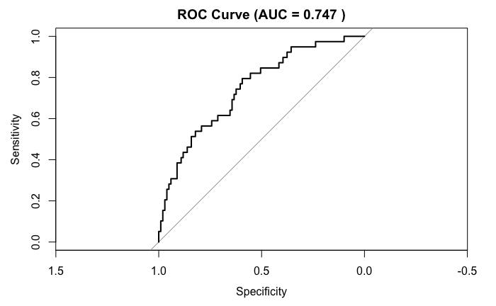
Figure 2.
Calibration Plot
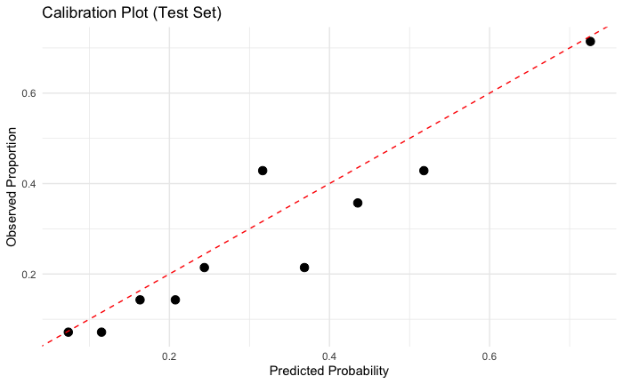

References
National Kidney Foundation. (2022, July 13). Estimated Glomerular Filtration Rate (eGFR). National Kidney Foundation. https://www.kidney.org/kidney-topics/estimated-glomerular-filtration-rate-egfr
NHS. (2023, February 15). Obesity. NHS. https://www.nhs.uk/conditions/obesity/
Tromp, J., Paniagua, S. M. A., Lau, E. S., Allen, N. B., Blaha, M. J., Gansevoort, R. T., Hillege, H. L., Lee, D. E., Levy, D., Ramachandran, V. S., van der Harst, P., van Gilst, W. H., Larson, M. G., Shah, S. J., de Boer, R. A., Lam, C. S. P., & Ho, J. E. (2021). Age dependent associations of risk factors with heart failure: pooled population based cohort study. BMJ, 372, n461. https://doi.org/10.1136/bmj.n461
Welsh, P., Campbell, R. T., Mooney, L., Kimenai, D. M., Hayward, C., Campbell, A., Porteous, D., Mills, N. L., Lang, N. N., Petrie, M. C., Januzzi, J. L., McMurray, J. J. V., & Sattar, N. (2022). Reference Ranges for NT-proBNP (N-Terminal Pro-B-Type Natriuretic Peptide) and Risk Factors for Higher NT-proBNP Concentrations in a Large General Population Cohort. Circulation: Heart Failure, 15(10). https://doi.org/10.1161/circheartfailure.121.009427
Yuan, Y., Pan, B., Wang, F., Chen, Z., Guo, Y., Shen, X., Liang, X., Liang, Y., Xing, Y., Zhang, H., Zhang, Y., Xie, C., Li, L., Huang, Z., Sun, H., Zheng, M., Liu, L., Lv, T., Li, Z., & Liang, X. (2025). Age‐Based Classification and Outcomes in Pediatric Heart Failure: Findings From a Retrospective Multicenter Cohort Study. Journal of the American Heart Association, 14(4). https://doi.org/10.1161/jaha.124.038129

